Beginning with the FY2021 grant reimbursement and budget revision requests, all submissions from grantees should be submitted through a Smartsheet form, and this link. This change is to improve the response time, improve DEED’s internal transparency, and provide for better cross coverage when team members are on leave.
Any submissions through the email eed.tls.grantsreimbursements@alaska.gov or tls.grantsrevisions@alaska.gov shall be returned to the sender with a request to submit using the new methodology.
Grantees must submit one request per form(submission); one reimbursement request or one budget revision. If multiple grant reimbursement requests are submitted on one form, they will be rejected. There is no limit on the number of submissions which can be made.
When the link is selected, this webpage will open,
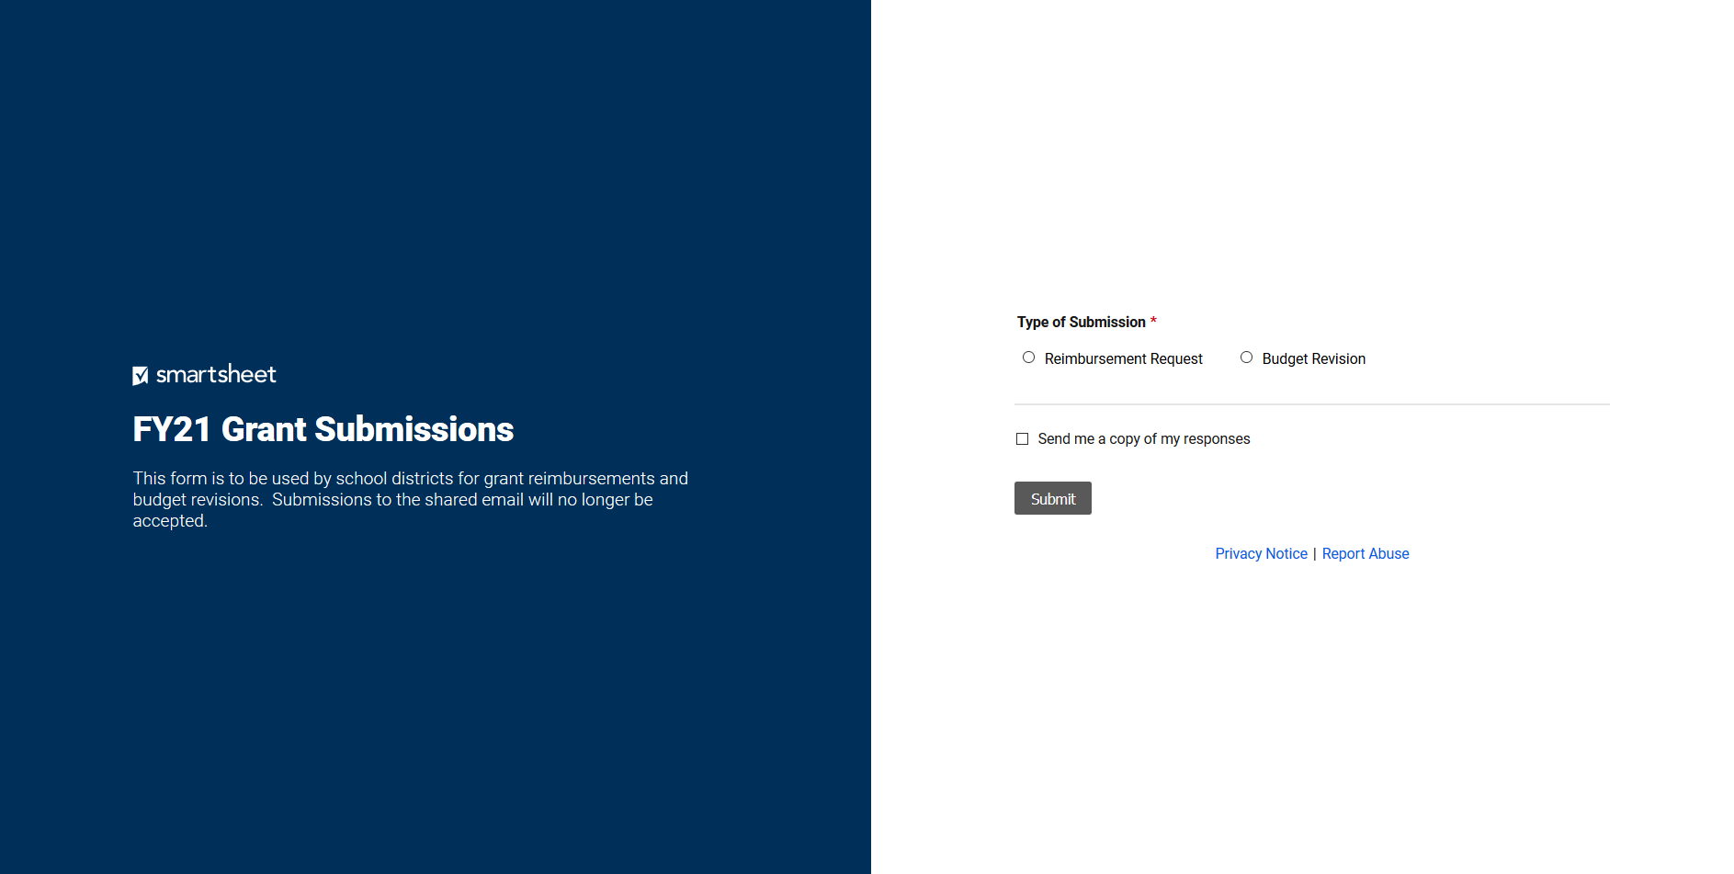
Select either Reimbursement Request or Budget Revision, depending on the item being submitted.
When Reimbursement Request is selected, the remainder of the fields will generate.
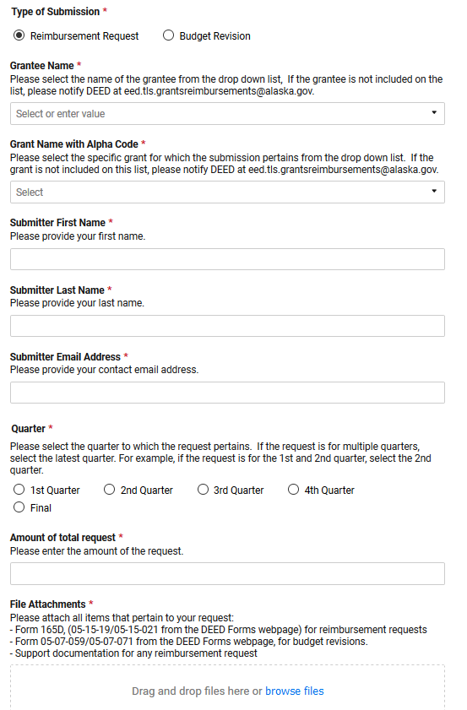
When Budget Revision is selected, the remainder of the fields will generate.
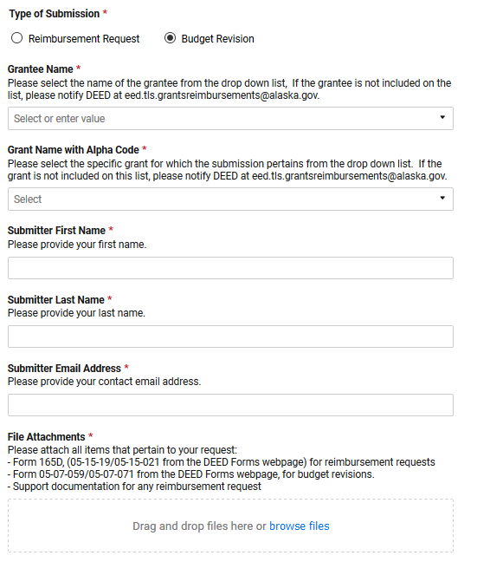
Both the reimbursement request and the budget revision form have a field for comments and the option to have a response sent to a specific address.
When the Send me a copy of my responses is selected, an email address box will generate.
When the Submit button is selected, the user can choose to submit another request.
When the submitter requests a copy, the email used will generate the following message.
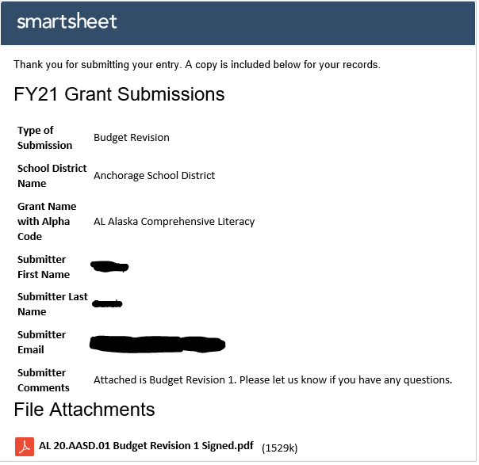
Questions or problems on this methodology should be directed to stephanie.allison@alaska.gov or (907)465-8696.
A Smartsheet account is not required to submit forms using this link. Smartsheet supports the following platform and browser combinations:
- Windows: Chrome (recommended for best performance), Firefox, Internet Explorer, Microsoft Edge
- Mac: Chrome, Firefox and Safari
- Linux: Firefox
- Chrome OS: Chrome

This methodology does not replace GMS, it only replaces the submissions through email, sometimes called “paper grants”.
Any item with a red asterisk requires a response in order to submit the form.

