Residential School Year-End Report

District:
School Name:
Date of Report:
Fiscal Year:

Table of Contents

INSTRUCTIONS 3
Part A – Questions and Excel Spreadsheet 4
Part B – Year End Program Summary 5
Signature Page 6
Appendix A – Statute 8
Appendix B – Regulation 10

INSTRUCTIONS

This is the required District-Operated Statewide or District-wide Residential School year-end report in accordance with Alaska Statute 14.16.200 and regulation 4 AAC 33.090(e).

The year-end report includes the completion of two parts: A) Final year-end spreadsheet and corresponding questions. B) The district’s one to three page narrative. Please see page three for items A and B.

- All required items must be addressed.

- Use 12-point font and number pages consecutively; footer with district name is desirable.

- The report must be completed by districts that operated a statewide residential educational program and is due to the department by June 30 of each year.

- Insure that the table of contents reflects the page number for each section of the application. To update the table of contents, highlight it and select F9; the page numbers will refresh automatically.

- Send the completed report to:
Department of Education & Early Development
Division of School Finance
P.O. Box 110500
Juneau, Alaska 99811-0500

If you need assistance or have questions in completing this report, please contact Meridith Boman at (907) 465-8683 or meridith.boman@alaska.gov.

Part A – Questions and Excel Spreadsheet

Answer the nine questions below by inserting your responses below each question.

For questions 4, 5 and 6 use the second tab on the same spreadsheet/workbook you used to report your October 1 count. The first tab was used for the October 1 count. The second tab is for this Year-End Report. You should be able to go back to your saved electronic spreadsheet from when you sent in the October count and click on tab two. The spreadsheet is designed so that your previously reported data in tab one is linked to tab two and you can complete columns H and I in tab two without re-entering student data. When you have completed tab two submit with this report.

1. What was the total number of applications received by the district for the residential school?

2. What was the total number of students accepted into the school?

3. Provide the total number of students accepted into the school that received state funding under the residential school. (This may or may not be the same as #2).

4. How many students were accepted into the school after the December 1 count period?

(Use excel spreadsheet tab 2, Year-End Report, enter any students added to the school that were not on the December 1 report and complete the corresponding data.

5. How many students withdrew from the school during the school year?

(Use excel spreadsheet tab 2, Year-End Report, and record the withdraw date for students leaving before the end of the school year. For variable-term schools, only include the number of students who withdrew prior to completing a session.

6. Provide the communities and district of residence for each student in the school at the time of application.

(You should have reported this information for each student claimed on the December 1 report. Reconfirm that your column D and E is correct. If you have added students after the December 1 submittal, or there are other changes to district and community, provide this information to the resaved spreadsheet.)

7. Provide a report of student academic achievements in the classroom.

8. Include the number of expulsions from the residential school during the school year. Do not identify individual students. Give a short discussion in general terms of reasons for expulsion; for example lack of academic performance, disciplinary issues or other reasons.

9. Did the program collect any tuition? If so provide dollar amount, source, and a short explanation.

Part B – Year End Program Summary

Provide a one to three page narrative summarizing the operations, activities and outcomes of your school for the fiscal year. Include pertinent information that will help the department understand changes in budgets, operations, facility plans, student enrollment and staffing levels. Include progress with the s standards and goals, along with program successes and failures for the year. Discuss the district’s plan for the coming year including anticipated enrollment levels. In addition to discussing the plan for the coming year, also include in calendar format the courses to be offered in the next school year.

Signature Page

The Superintendent’s signature on this report serves as confirmation of the information contained in the district’s year-end report for the statewide or district-wide residential school under AS 14.16.200 State funding for districts operating statewide or district-wide residential schools and 4 AAC 33.090 (e) District-operated statewide or district-wide residential schools.

Further, the information provided in this year-end report is correct.

Further, the district has complied with the law and regulations under which this program operates.

Superintendent Signature: Date:
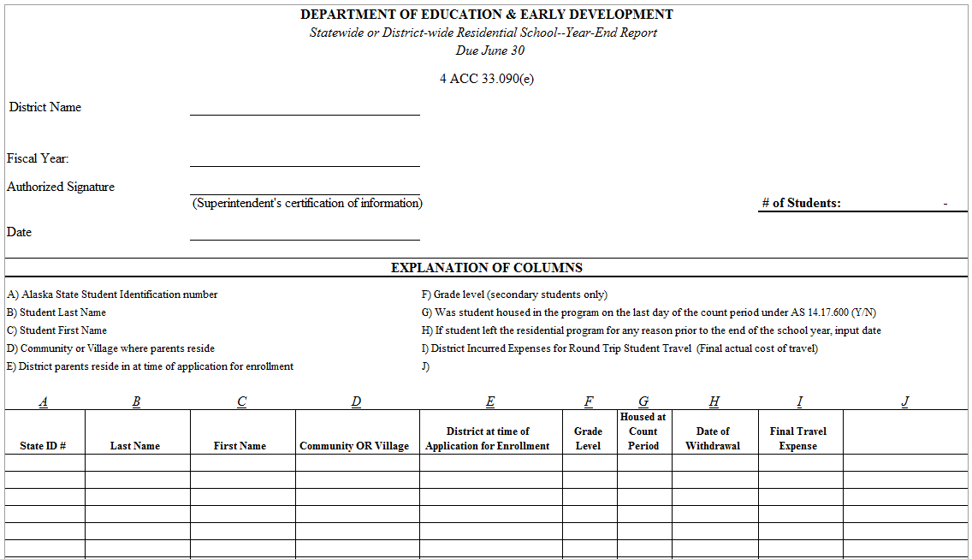

Note: This spreadsheet is the second tab or your original submittal from December 1st. Columns A thru G are linked from the first tab. Complete columns H and I then add any additional students to the bottom of the page that were not reported on December 1st report.

Appendix A – Statute
Chapter 14.16. SPECIAL SCHOOLS
Article 02. SCHOOL DISTRICTS OPERATING RESIDENTIAL SCHOOLS
Sec. 14.16.100 Application for residential school.
Before establishing a residential school, a school district shall apply to the department for approval to establish and operate a statewide or district-wide residential school. The department shall accept applications during an open application period conducted annually. A period of open application in itself does not indicate that the department will approve the establishment of a new residential school. (§ 22 ch 15 SLA 2014; am § 19 ch 22 SLA 2015)
Sec. 14.16.200. State funding for districts operating residential schools.
(a) A district that operates a statewide or district-wide residential school for students in grades nine through 12 that has been approved by the department under regulations adopted by the board is eligible to receive a boarding stipend as reimbursement for the costs incurred by the district in operating that school. To be eligible for reimbursement for costs, a statewide or district-wide residential school operated by a district must provide a suitable student dormitory, food service, and daily access to a public school offering the appropriate grade level for a variable-length or 180-day school term as provided under AS 14.03.030 for the full school year.
(b) Costs that may be claimed by a district for reimbursement under (a) of this section are
(1) one round trip on the least expensive means of transportation between the student’s community of residence and the school during the school year if the district expends money for the trip; and
(2) a per-pupil monthly stipend to cover room and board expenses as determined by the department on a regional basis and not to exceed the following amounts:
(A) for the Southeast Region (Region I), $1,230;
(B) for the Southcentral Region (Region II), $1,200;
(C) for the Interior Region (Region III), $1,452;
(D) for the Southwest Region (Region IV), $1,509;
(E) for the Northern Remote Region (Region V), $1,776.
(c) [Repealed, § 4 ch 48 SLA 2013.]
(d) A district may cooperate with an Alaska Native organization, as defined in 20 U.S.C. 7546(2), or a nonprofit organization for the provision of room and board services to students enrolled in a statewide or district-wide residential school operated by a district under terms and conditions required for licensing in the state and as specified by the department in regulation.
(e) In this section, “district” has the meaning given in AS 14.17.990. (§ 1 ch 54 SLA 2006; am § 1 ch 7 FSSLA 2011; am §§ 1 — 4 ch 48 SLA 2013; am § 23 ch 15 SLA 2014)

Appendix B – Regulation
ALASKA ADMINISTRATIVE CODE
4 AAC 33.090. District-operated statewide residential educational programs

(a) A district must obtain approval from the department before operating a statewide or district-wide residential school. A district may apply to establish and operate a new school only during a period of open applications established by the department under (c) of this section. Applications must include

(1) designation of the facilities that will house the residential school, including any proposal to build or renovate a facility, and the revenue sources that will support the construction or renovation;

(2) a five-year budget for the operation of the residential component of the school; the budget must specify the revenue sources that will support the proposed budget, including a provision for charging student tuition;

(3) a tuition waiver policy for families that can demonstrate financial hardship, including a definition of "hardship";

(4) an enrollment and selection policy for students applying to attend the residential school;

(5) a list of course offerings;

(6) a plan to assist students in crisis; and

(7) a staffing plan for the school.

(b) The department may require that a district supplement its application with additional information. The department may require a district to change its policies or proposed practices before approving an application. A district must operate the residential school in conformance with its approved application. A district that wishes to change any of the requirements of an approved application must submit a revised application. In determining whether to grant or deny an application, the department will consider

(1) whether the community in which the school is located has sufficient infrastructure to support the residential school;

(2) demand, current capacity, and regional needs for residential schools;

(3) the cost to provide a residential school in the applying district;

(4) the district's ability to offer a high-quality academic program to students;

(5) the health and welfare of students housed in the residential school, including the ability of the district to offer a high-quality residential school;

(6) for a revised application, whether the school has complied with the policies and practices that the district identified in its current application; and

(7) the public interest.

(c) The department will open a period of application annually on May 1. The application period will close on June 30. The department may require that applications be targeted to provide a particular program to meet specific needs of students in the state. A period of open application and solicitation does not imply that the department will approve the establishment of any new schools.

(d) This section does not prevent a governing body from establishing an in-district residential school that is not eligible for state support for the operation of the residential aspects of the school.

(e) A district that operates an approved statewide or district-wide residential school shall submit an annual report to the department. The report must include the

(1) number of applications received by the school;

(2) number of students accepted into the school;

(3) students' communities and districts of residence at the time of application for enrollment;

(4) students' academic achievement results;

(5) date of, reason for, and number of withdrawals from the school during the school year;

(6) number of expulsions from the school during the school year;

(7) number of students receiving a tuition waiver; and

(8) other information requested by the department with respect to the school.

(f) On December 1 of each school year, a district that operates an approved statewide or district-wide residential school shall submit to the department an application, on a form provided by the department, for payment of a stipend under AS 14.16.200 (b)(2). The district is eligible for payment of the lesser of actual cost to house the student or the amount allowed in AS 14.16.200 (b)(2) for each residential student who is housed by the district on the last day of the student count period under AS 14.17.600 , and whose parents or guardians do not reside in the community in which the school is located. If appropriations are insufficient for the residential component of approved statewide or district-wide residential schools, the department will reduce each district's entitlement by a pro rata amount as determined by the department.

(g) The department may withdraw its approval for a district to operate a statewide or district-wide residential school if the department determines that continued operation of the school is not in the public interest. In making this determination, the department will consider

(1) the health and safety of the students in the residential school;

(2) whether students at the school have demonstrated sufficient academic achievement; in making this determination, the department will consider all evidence of student academic achievement and improvement, including evidence of

(A) students' scores and improvement of students' scores on statewide student assessments under 4 AAC 06.710; and

(B) the program's record of demonstrating progress in accordance with 4 AAC 06.800 - 4 AAC 06.899 (school and district accountability) and the reasons for its success or failure to demonstrate progress;

(3) the demand for the school;

(4) the cost of operating the school;

(5) whether the school has complied with the policies and practices that the district identified in its application; and

(6) the existence of alternative methods of meeting the needs of students.

(h) A district may apply during a period of open application under (c) of this section for approval to operate a variable-term statewide or district-wide residential school that will house students for the entire school calendar. The minimum term for each student must be at least two weeks. A variable-term school is eligible for reimbursement for a monthly stipend for up to nine months of the school year under (f) of this section for the number of students that it housed on the last day of the student count period under AS 14.17.600 if the district will continue to house at least the same number of students throughout the entire school term. Upon the written request of a school district, the commissioner may permit a district to report the number of students it housed on a date other than the last day of the student count period if the date is within the count period set out in AS 14.17.600 and the date more accurately reflects the numbers of students the district will house throughout the school term. A variable-term school is eligible for a one-time air fare reimbursement under AS 14.16.200 (b)(1) for the number of students housed by the school on the last day of the student count period, based on the average cost of round-trip air fare for all statewide or district-wide residential schools. A district may not include students housed by a variable-term school in the school's student count submitted to the department for foundation funding under AS 14.17; a student being housed by a variable-term school during the student count period may be included in the count of the student's district of residence. In this subsection, "variable-term statewide or district-wide residential school" means a statewide or district-wide residential school that rotates students in and out of the school during the school year for the entire school term as defined under AS 14.03.030 .

History: Eff. 10/22/2006, Register 180; am 6/8/2013, Register 206; am 10/16/2013, Register 208; am 2/21/2014, Register 209; am 3/6/2015, Register 213

Authority: AS 14.07.020
AS 14.07.060
AS 14.07.165
AS 14.16.100
AS 14.16.200

