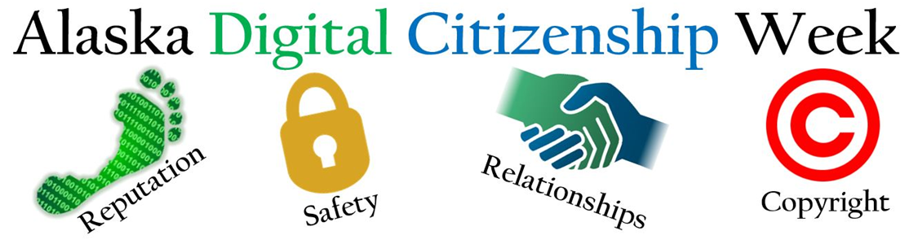
We appreciate that you are supporting your students by taking part in Alaska Digital Citizenship Week! We have put together THREE ways to participate in the daily themes which begin on Tuesday. By completing the Curriculum Tutorial on Monday and teaching lessons, you are well on your way to being Common Sense Certified! Whether you pursue certification or not, you are making an impact on our students’ success as members of a digital society.

Choose the activity or combination that best suits you and your students’ needs:
- Teach a 45-minute lesson. Each lesson has three delivery options: low/non tech, iBooks, and Nearpod. If time is tight, teach one suggested specific activity from the aligned lesson (linked in the chart below under Lesson).
- Show and discuss the highlighted video. This is the way to go if you only have 5-10 minutes to introduce the theme of the day.
- Share the corresponding Family Tips Sheets (linked in chart).
3-5 | Monday  Educate Yourself | Tuesday  Media Balance and Well Being | Wednesday  Privacy and Security | Thursday  Digital Footprint and Identity | Friday  Relationships and Cyberbullying
Lessons  45 minutes | Use today to create your account of Common Sense Media and begin exploring the digital citizenship curriculum and training. | My Media Choices  What makes a healthy media choice? | Pass word Power-Up  How can a strong password help protect your privacy? | This Is Me  How does what I post online affect my identity? | Is It Cyberbullying?  What is cyberbullying and what can you do to stop it?
Video options that may have Discussion Guides |  | Finding My Media Balance 1:18 | Private and Personal Information 1:20 |  | The Power of Words 2:42  Be Super Digital Citizen 1:58
Family Tip Sheets | We encourage school leaders to send this letter home digitally or with students. | Help Kids Balance Their Media Lives | Help Boost Kids’ Safety, Privacy and Security | Help Kids Post, Comment, and Upload Responsibly | Help Kids Fight cyberbullying and Other mean Online Behavior

